SWINBURNE VIETNAM
HO CHI MINH CAMPUS


COS30018 - COS30018-Intelligent Systems
Week4: Task C.1

INSTRUCTOR: MR. KY TRUNG PHAM
STUDENT NAME: LÊ TIẾN DŨNG-SWS00683

HO CHI MINH CITY – JAN-2026

Contents
1. Summaries of your attempt to setup your environment, including details of your requirements file. 4
2. Summaries of your attempts to test the provided code bases (v0.1 and P1) with screenshots. 4
3. Summary of your understanding of the initial code base v0.1. 6
Oral Defense week 4 6
1. Explain the differences you observed between the initial code (v0.1) and the GitHub project (P1). Which one provided better initial results, and how did you define "better"? 6
2. Why is it highly recommended to use a virtual environment for this project, and what are the key libraries included in your requirements.txt? 7
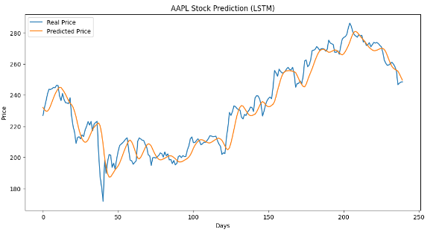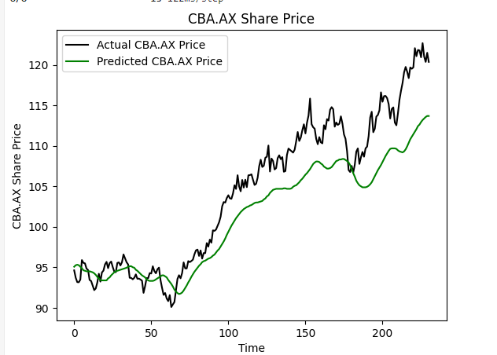 8

1. Summaries of your attempt to setup your environment, including details of your requirements file.
A standalone Anaconda environment was created for this course and the following dependencies were installed via pip:
numpy, matplotlib, pandas, tensorflow, scikit-learn, pandas-datareader, yfinance, jupyter, and
ipykernel.
This setup enabled successful execution of the provided baseline code for this week's task.

2. Summaries of your attempts to test the provided code bases (v0.1 and P1) with screenshots.

v0.1 (.ax): Executed successfully after installing the correct libraries. The pipeline ran end-to-end
and produced stock price predictions using an LSTM model.


P1: Initial execution failed due to missing dependencies such as 'websync' not being listed in the
requirements file and the yahoo-fin source no longer working reliably. Substituting yahoo-fin with yfinance resolved the data retrieval issue.


3. Summary of your understanding of the initial code base v0.1.
v0.1 contains a straightforward LSTM forecasting pipeline including data loading, scaling, sequence windowing, model construction, training, and visualization. The structure is clear and suitable forlearning purposes.

Oral Defense week 4

1. Explain the differences you observed between the initial code (v0.1) and the GitHub project (P1). Which one provided better initial results, and how did you define "better"?
The main difference between v0.1 and P1 lies in implementation robustness and prediction behavior. The v0.1 version is a simpler baseline LSTM model which uses fixed training and testing dates. The model produces smoother predictions which exhibit time delays when compared to actual price movements. P1 required dependency fixes to run properly but its predictions matched price trends better because it tracked short-term price movements more accurately.

P1 provided better initial results. In this context, "better" was defined as producing predictions with lower expected errors, reduced temporal lag, and closer visual alignment with actual stock price movements.

2. Why is it highly recommended to use a virtual environment for this project, and what are the key libraries included in your requirements.txt?

The project needs a virtual environment because its code requires specific machine learning and data processing library versions which will clash with the system's existing globally installed packages. The virtual environment provides three main benefits which include separating dependencies and enabling users to replicate their work across various machines and execution times. TensorFlow-based projects require this aspect because version mismatches lead to both runtime errors and compatibility issues.

The project needs to use NumPy and Pandas as its main numerical computation and data manipulation libraries while it requires Matplotlib for graphics and TensorFlow to build and train an LSTM model and scikit-learn for data preprocessing and scaling and pandas-datareader and yfinance to obtain financial time-series data and Jupyter/ipykernel for interactive development and testing.



